These pages are designed to show you how to use software packages; various software updates may have taken place so some pages will not apply to versions other than those listed here. In some cases data files may be required.

Title or Task: | Making a Dreamweaver Site    
Description: | Create a web site

Files Required
Suitable for Classes: | AIT • Multimedia • Cert II IT • Cert II Bus
Area: | Technology & Enterprise
Teacher: | Mr Peter Faulks
Timeline | 1 Lesson

Date Due:
Task Brief: | Create a folder (site) and first page
Outcomes: | Ability to use web authoring tool like Dreamweaver

Items highlighted in yellow are tasks for you to complete
Items in Blue italics are help tips

______Your Marks

ADW100 : Making a Dreamweaver Site (CS3 version) and your first page

Terminology
HTML: Stands for Hyper Text Markup Language (the language of the internet)
Splash Page: Your opening web page
Index.html: Your main page

Note Items in italic or blue are tips or tricks to help.

Items numbered and shaded indicate your task or involvement

What is Dreamweaver
Dreamweaver is an HTML editing facility produced by a company called Macromedia. It is used to produce HTML files - otherwise called web pages.
One HTML file can be called a web page (or document). Several web pages that have been linked together can be called a web site.

How Dreamweaver works
Dreamweaver can also be used to create HTML files or to edit HTML files that have been written in other applications.

Introductory Notes
Your First page: Commonly known as a SPLASH PAGE
A Splash Page is the opening page of a website usually opens quickly with limited pictures, logo or corporate designs this is saved in a page called index.htm or index.html (all sites should start with an index.html)

Your lesson starts next page

Making a web page

Site
All web pages are assembled in a site folder, this is simply a folder where you must store the pages and images. When using the site ensure you keep the folder in the same location, moving the files or folders outside of Dreamweaver may cause links to break and loss of site integrity.

Site ADDRESS
All sites MUST HAVE a splash paged labels index.htm or index.html

Open Dreamweaver

Defining a Site in Dreamweaver

First create the site folder
(Everything belonging to the site MUST live in here)
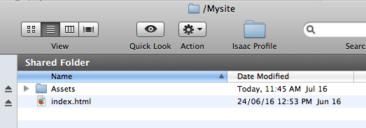

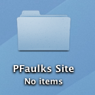
Create a folder called Mysurname site i.e. Pfaulks Site onto your computer or thumb drive, OR you should create a folder in your own shared folder for whatever class and age you are in i.e. for Applied Information Technology this would be called Y11AIT and a folder in here for task number or term i.e. Term 1 , Term 2, Term 3 or Term 4 – Select the appropriate folder for the current term.

Next - resume with our tutorial…
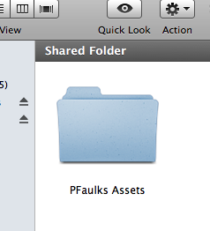

You have now created a folder called My Surname Site - you might give it a name that suits your web site or school topic, (Mine is just named Pfaulks Site) and inside this folder create another folder called Your Surname Assets

- Open Dreamweaver if it is not already open

- Click on Site menu and New Site

Dreamweaver has a built-in tool that will allow you to manage your site or sites.

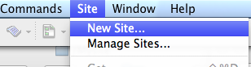

Ensure you are in Advanced and Local Info view - you should now have created…
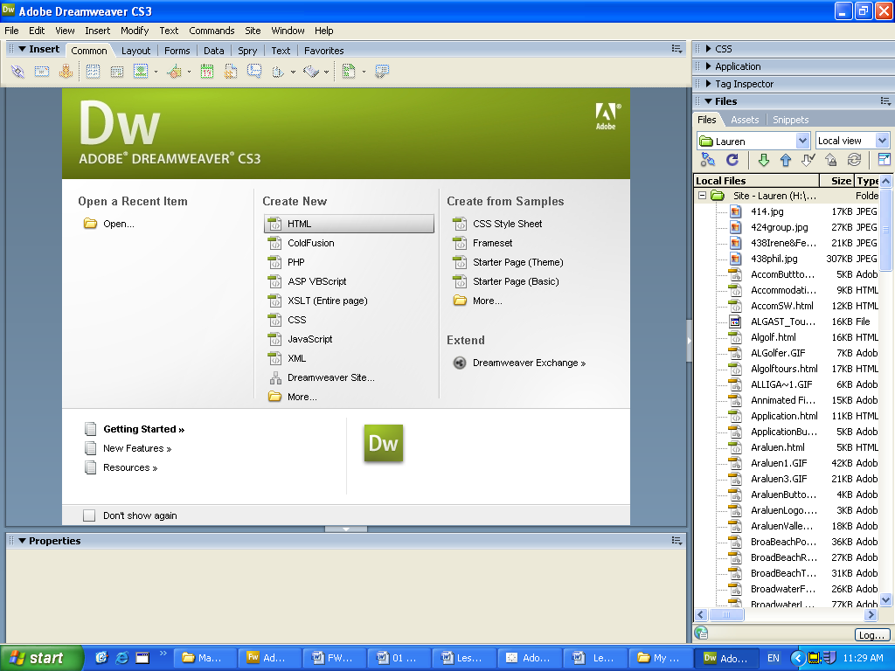
- A folder in your workspace called Mysite
- A folder inside this called assets
- Now create your first page

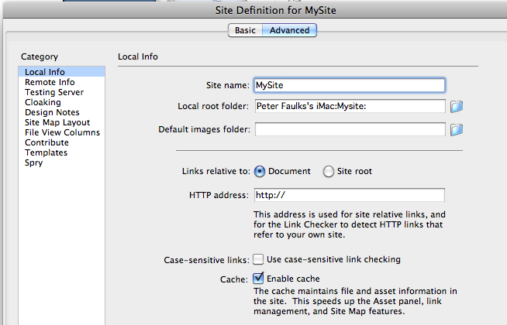

- Enter the Site name your surname and

- In the Local Root folder - click on the small folder icon on the right, to take you to your computer,

- then browse for your folder called yoursurname Site on your drive or workspace (This will be your folder with your name)

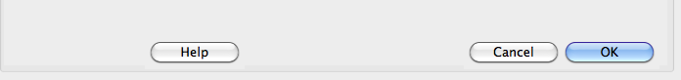

- Select the folder you named (yoursurname Site) by clicking on it ONCE then
- click on CHOOSE
- Click OK

The link will appear in the Local root folder window

If asked for server technology click on NO

- If asked how do you connect click none from the drop down menu select

Picture 2

Click on NEXT

FIRST PAGE usually called index.html
If you have not got a new page we will create one now.

Click on File New in Dreamweaver Select HTML then click Create

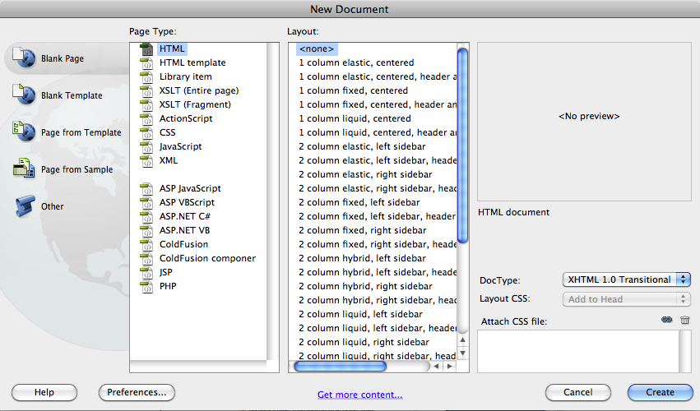
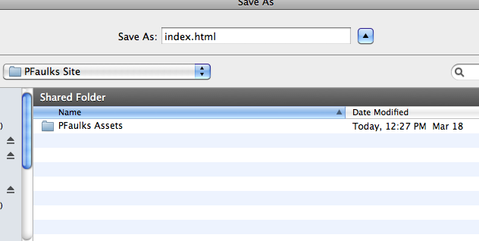

FOR AIT STUDENTS OPEN

AITclass_template.html

Change the AIT Stage to 1, 2 or 3

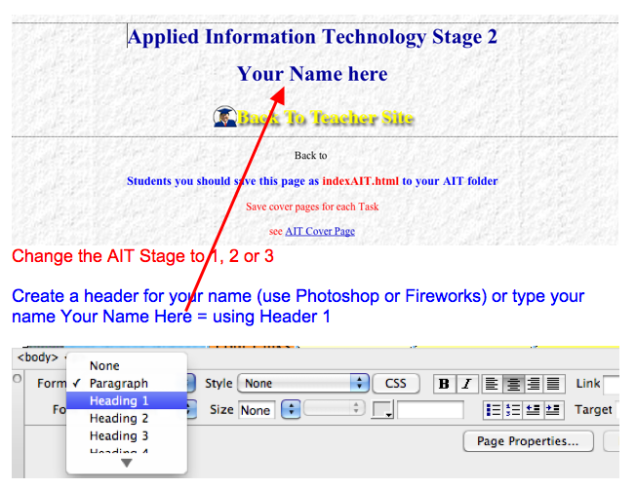

Save the page as indexAITyour initials.html

to your AIT folder

Next change the link of your tasks as provided in the Task List Link 1

Save as
indexAITyour initials.html

To your AIT folder

Create 5 more folders

Cover Page AIT

Students should create a cover page for each task during week 1 and save each page to their folder (save only the next page after you have entered information):- i.e.

Your initials_task1.doc into Term 1 then into Task 1
Your initials_task2.doc into Term 1 then into Task 2 etc.

Create these folders inside the AIT?? Folder

- Task 1

Inside AIT2
- Task 2
- Task 3
- Task 4

- Task 5
- Working Notes Images
- Marking Folder
Save the document as
Your initials_task1.doc into Task 1 folder
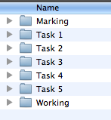
I will look at this in 5 minutes
AIT2 Term 1 Folder

This will complete today’s lesson
Save the set of folders to a Flash Drive if you have one (Always backup your work)

PJF_Task1.doc save to Task 1
PJF_Task2.doc save to Task 2
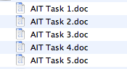
PJF_Task3.doc save to Task 3
PJF_Task4.doc save to Task 4

Unit Title (Class)
Teacher / Unit Controller:
Peter Faulks

ASSIGNMENT TITLE

Picture of you

Due: Friday 15th August, 2015

Length: 1500 words

Topic: Title

Date Due: by 3:00pm

Worth: 20%

“I declare that this is my own work and has not been submitted, in part or in whole, for any other unit”

__________________________ Signed

NAME: Ima Student

STUDENT ID: 12345678

Email: imastudent@westnet.com.au

MARK/GRADE:
Your web site should now be inside your folder create an Assets folder

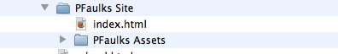

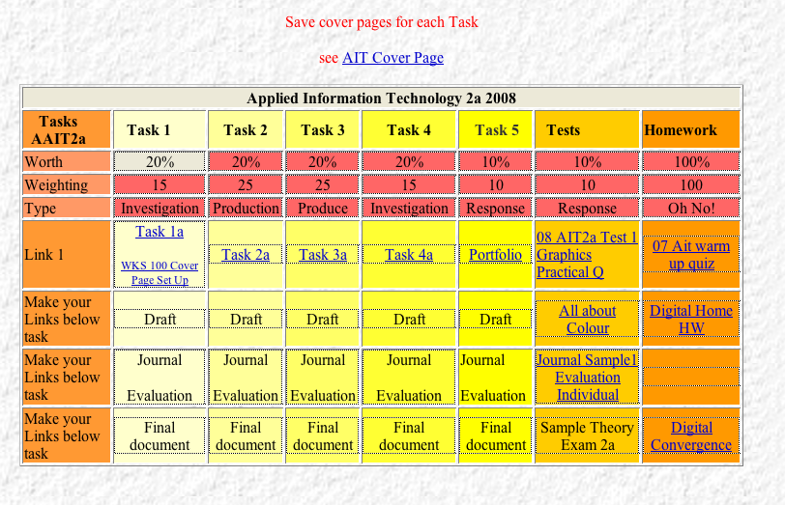

Next lets look at our opening screen with some explanations

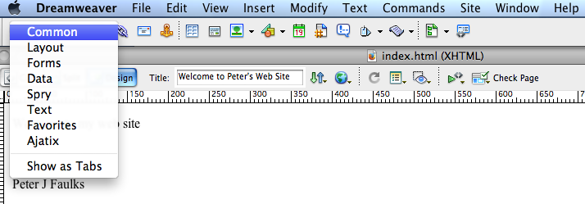
The top bar can have various toolbars, we will use Common for most of the early work. Your screen should show your files (on the right) and working page in Design View with the Common Toolbar and Properties window at the bottom, here is what it might look like…
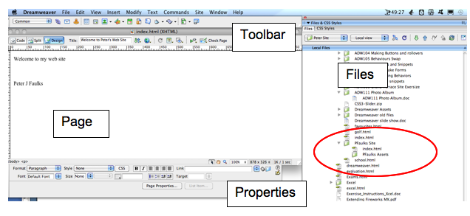

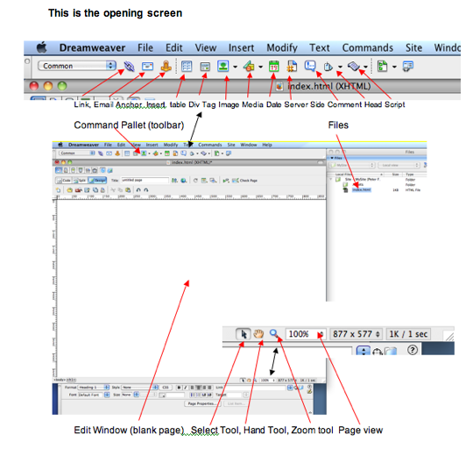
image version

Here are some explanation of the components

Properties Pallet

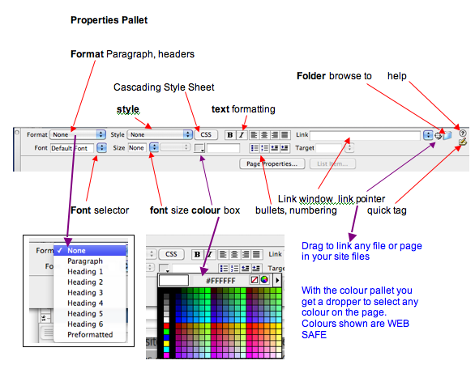

Getting started

Now we can enhance our first page

Open Dreamweaver from the Programs Menu if you have not already done so, create a new page (if you have not already done so)

Tip: keep the property inspector open and on the screen at all times. If you loose it, go to the WINDOW menu and reselect it from the drop down list.

Type your name (if you have not already done so)

Highlight your name, Select Heading 1 from the Paragraph drop down, Center the text and choose a color for the text.

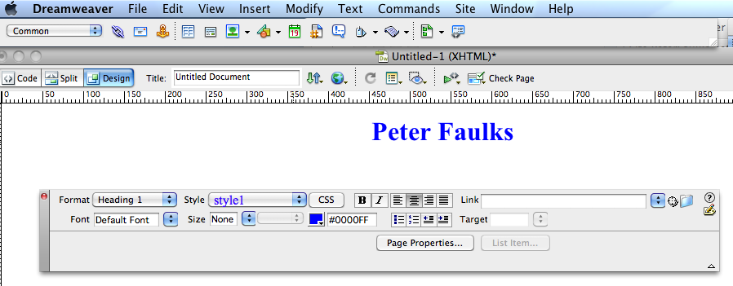

Heading Font Colour Center

Save this page as index.html (over write the file)

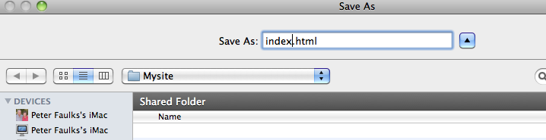

Now we will give the page a title, change the page background colour and save it
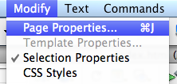
Open page properties (Modify - Page Properties) and
select the background colour
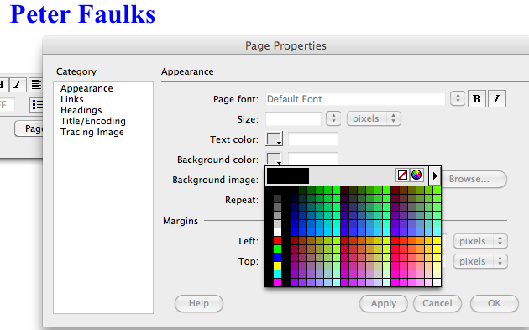

Select a colour Click Apply then OK
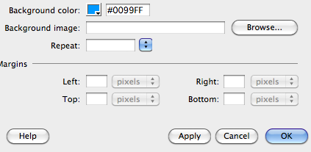

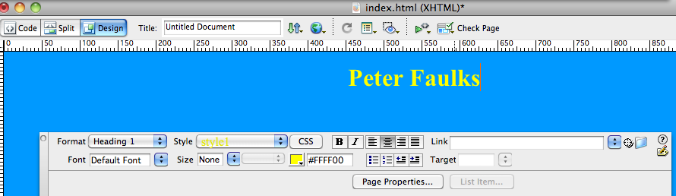
Title the page Welcome to ?????’s Page (use your name)

Change the Font colour to enhance your text

Hit Save

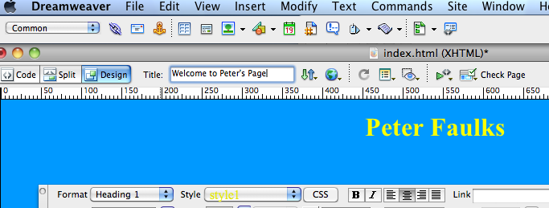

You have successfully create your first web page

You have made your first web page

